**NEW – WATCH THE VIDEO I HAVE UPLOADED TO THE TRAINING VIDEO SECTION ON STUDYSPACE**

**Automatic coppercube file convertor**

I’ve written a program called coppercubeconvert.exe to simplify the output when exporting an irrlicht scene and loading it into your irrlicht program. If you follow the steps below you will create a file called convertit, and all you need to do is double click on this file every time you export and the program will do all the rest for you.

The source file is included in the folder K:\Teaching Materials\CI\CI5510\coppercubeconvert . You only need the file K:\Teaching Materials\CI\CI5510\coppercubeconvert\coppercubeconvert\coppercubeconvert\Release\coppercubeconvert.exe

**Where to place media files**

All media files should be placed in the folder

C:\apps\irrlicht-1.8\irrlicht-1.8\media **OR 1.8.1 depending on which version is installed**

**Setting up Instructions**

Copy coppercubeconvert.exe into C:\apps\irrlicht-1.8\irrlicht-1.8\media

Copy irrlicht.dll into C:\apps\irrlicht-1.8\irrlicht-1.8\media

Copy convertit.bat into C:\apps\irrlicht-1.8\irrlicht-1.8\media

Edit convertit.bat

Change myscene to whatever yours is called

Create a file called convertit.bat and in this file add the line below

coppercubeconvert C:\apps\irrlicht-1.8\irrlicht-1.8\media myscene.irr

**In coppercube**

From coppercube export your model using “File / Export / Export Current Scene as Irrlicht Scene”

Leave application working directory blank

File to export to will be for example:

C:\apps\irrlicht-1.8\irrlicht-1.8\media\myscene.irr

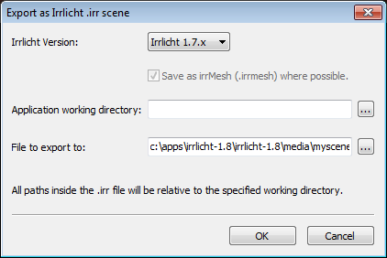

**To do the conversion**

Double click on “convertit” in the media folder

NOTE: You **CANNOT** export prefabs into irrlicht.

You **CANNOT** export animations into irrlicht. They have to be coded within irrlicht.

You **CANNOT** export specialfx into irrlicht. They have to be coded within irrlicht.

You **CANNOT** export terrains into irrlicht. They have to be coded using ScapeMaker.

If you want to export an animated character, then you need to add it to coppercube using “insert / import an animated mesh”. You need to have the actual model file, such as an md2 file.

**To test your game level**

Look at example 15 as we did in the workshop

// load the scene

if (argc>1)

smgr->loadScene(argv[1]);

else

smgr->loadScene("../../media/myscene.irr");

Look for the line above and ensure ../../media/myscene.irr is edited if necessary, for example it could be “c:\\apps\\irrlicht-1.8\\irrlicht-1.8\\media\\yourscene.irr”

Run the program:

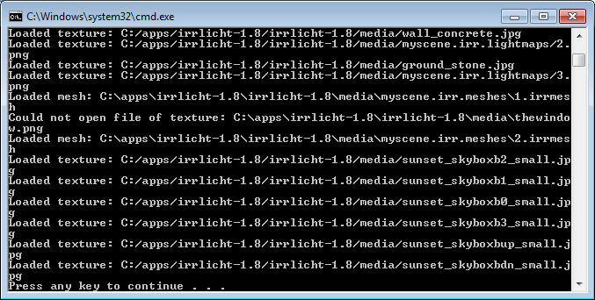

If any textures cannot be found it will say “could not open file”. You need to find where these files are on the system and copy them to the media folder.

**DoorDemo2**

You may also want to look at the example DoorDemo2 . This has a door which can be opened by moving to the door opener and pressing the “E” key, and also a npc which tracks you. You could use this as a template for your coursework if you wish.

Everytime you edit your game level in coppercube, you must export it and click on convertit